LTE Network Optimization in Nagari Ulakan and Tapakis, Ulakan Tapakis District, Padang Pariaman Regency

Nugraha Saputra¹, Zurnawita Zurnawita ^{2*}, Firdaus Firdaus ³
^{1,2,3}Politeknik Negeri Padang, Indonesia
¹nugrahasaputra041@gmail.com, ²zurnawita@pnp.ac.id , ³firdaus@pnp.ac.id

  *Corresponding Author | ABSTRACT  This study aims to optimize the Long Term Evolution (LTE) network in Nagari Ulakan and Nagari Tapakis. The development of mobile telecommunications technology requires improvements in network coverage quality to accommodate increasing user demand and the need for high-speed, reliable data services. Challenges arise due to complex geographical and demographic conditions, which cause signal weaknesses (bad spots) that interfere with service quality. The methodology involves collecting performance data through drive tests using G-Net Track Pro, collecting parameters such as Reference Signal Received Power (RSRP), Reference Signal Received Quality (RSRQ), and Signal to Interference Noise Ratio (SINR) from XL Axiata (AXIS). The data was then analyzed to identify performance deficiencies. Network optimization was performed through Automatic Cell Planning (ACP) using Atoll software, enabling better coverage efficiency without the need for significant infrastructure expansion. The results showed significant improvements in key signal quality parameters, especially in previously problematic areas, after applying optimization techniques.
Article History:
Submitted: 26-01-2026
Accepted: 30-01-2026
Published: 04-02-2026
Keywords:
Long Term Evolution (LTE); drive test; optimasi jaringan; Automatic Cell Planning (ACP); Reference Signal Received Power (RSRP); Reference Signal Received Quality (RSRQ); Signal to Interference Noise Ratio (SINR); Padang Pariaman.
JATAED: Journal of Appropriate Technology for Agriculture, Environment, and Development is licensed under a Creative Commons Attribution- NonCommercial 4.0 International
(CC BY-NC 4.0).

INTRODUCTION
Advances in information and communication technology have driven transformation in the mobile telecommunications sector, particularly through the evolution of network technology from 1G to 5G. LTE, a 4G technology developed by the 3rd Generation Partnership Project (3GPP), has the capability to support high-speed data and multimedia services. The increase in network capacity and speed has a direct implication on the growth in the number of users, thus requiring the availability of adequate infrastructure to maintain service quality. However, problems such as poor signal quality and limited network access still often occur due to technical factors, such as blocking, interference, minimum range, and other technical factors that can be the cause of both problems [1]. Padang Pariaman Regency is one of the areas that still faces challenges in equalizing telecommunications network access, especially in Ulakan Tapakis District, which has complex geographical characteristics in the form of coastal areas, lowlands, hills, and small islands, thus triggering an imbalance in signal distribution and the emergence of blank spots. Based on data from the Badan Pusat Statistik (BPS) Padang Pariaman Regency in 2024, the population of this subdistrict reached 59,233 people [2]. This subdistrict has a number of popular tourist attractions, such as Tiram Beach, Ulakan Beach, Pieh Island, Green Talao, and the Makam Syekh Burhanuddin religious tourist area [3]. In 2024, the total number of tourists reached around 600,000 people, an increase from 2023, which recorded around 525,545 visitors. [4] In 2024, the total number of tourist visits reached around 600,000 people, an increase from 2023, which recorded around 525,545 visitors [4]. The increase in population, tourism activities, and the intensity of digital service usage also affects the performance of the LTE network in the region. Therefore, network planning and optimization efforts are needed to improve service quality and support regional development [5]. This research focuses on the analysis and optimization of the LTE network in Nagari Ulakan and Nagari Tapakis through the measurement of the Reference Signal Received Power (RSRP), Reference Signal Received Quality (RSRQ), and Signal to Interference plus Noise Ratio (SINR) using the application of the Automatic Cell Planning (ACP) method as an efficient approach to improve network coverage and reduce bad spot areas without adding new sites.

LITERATURE REVIEW

LTE (Long Term Evolution)
Long Term Evolution (LTE) is a fourth-generation cellular network technology developed by the 3rd Generation Partnership Project (3GPP) to meet the needs of high-speed data and multimedia services. LTE is designed to transmit data and access multimedia services such as voice and video at high speeds, with downlink speeds of up to 100 Mbps and uplink speeds of up to 50 Mbps [6], on a 20 MHz bandwidth with high spectrum efficiency through the application of Orthogonal Frequency Division Multiple Access (OFDMA) on the downlink and Single Carrier Frequency Division Multiple Access (SC-FDMA) on the uplink. LTE is capable of providing greater coverage and service capacity, reducing operational costs, supporting the use of multiple antennas, being flexible in bandwidth usage, and being able to connect or integrate with existing technologies [7].

LTE Network Architecture
The LTE network architecture is known as System Architecture Evolution (SAE), which is all-IP based and consists of the Evolved Packet System (EPS), which includes the Evolved UMTS Terrestrial Radio Access Network (E-UTRAN) and the Evolved Packet Core (EPC) as its main components [8]. E-UTRAN consists of eNodeB, which functions as a base station to manage radio connections, data transfers, and control signals between User Equipment (UE) and the core network. EPC plays a role in mobility management, authentication, service policies, and data traffic management, which is implemented through key components such as Mobility Management Entity (MME), Home Subscriber Server (HSS), Serving Gateway (S-GW), Packet Data Network Gateway (PDN-GW), and Policy and Charging Rules Function (PCRF) work together to manage data traffic, mobility, and policies within the LTE network [9]. Communication between network elements is facilitated by various interfaces such as S1, X2, S5/S8, S6a, S11, Gx, and the Uu air interface.
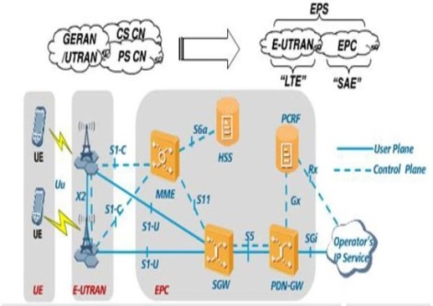
Figure 1. LTE Network Architecture

Drive Test
A method for measuring signal quality and testing telecommunications networks by collecting network performance data directly and in real-time in the field and involves checking through various routes. Drive tests measure and assess the coverage, capacity, and quality of service (QoS) of mobile radio networks. This device will measure various network parameters, such as signal strength, signal quality, and latency [10, 11]. This method can be carried out in outdoor or indoor conditions. Drive tests can be performed in idle mode to measure signal strength, as well as in dedicated mode to evaluate voice and data service quality. Based on the purpose of the measurement, drive tests can be classified into Single Site Verification (SSV), cluster tests, inter-operator benchmarks, and network optimization testing.

Key Perfomance Indicator
The parameters analyzed in this study refer to commonly improved parameters such as RSRP, SINR, RSRQ [12]. RSRP (Reference Signal Received Power) is a parameter of the LTE network signal strength received from the eNodeB to the user and exists at every coverage point. Meanwhile, users who are outside the coverage area will not receive LTE services. RSRP represents the reference signal strength received by the UE from the eNodeB and is used to assess network coverage. RSRP provides information to the User Equipment (UE) regarding the signal strength of a cell [13]. The range of RSRP is shown in Table 2.1.
Table 1. RSRP Parameters
Category | RSRP (dBm)
Excellent | RSRP ≥ -75
Very Good | -85 ≤ RSRP < -75
Good | -100 ≤ RSRP < -85
Fair | -110 ≤RSRP < -100
Poor | RSRP <-110

RSRQ (Reference Signal Received Quality) is the ratio between RSRP and Widebandpower, the quality of the signal received by the UE (user equipment), affected by the signal, noise and interference received by the UE, reflecting the relationship between the received signal strength (RSRP) and the overall signal strength including interference and noise. RSRQ provides information about the efficiency of signal usage in noisy environmental conditions in network optimization to ensure that users get good signal quality. RSRQ assists the system in the handover process by sorting the quality of candidate cells for handover. As a ratio between the number of resource blocks and the average linear power received by the user. The unit of RSRQ is dB [14]. Table 2.2 shows the standardization of RSRQ signal strength values in dB units.
Tabel 2. RSRQ Parameters
Category | RSRQ (dB)
Excellent | ≤ -9
Very Good | -10 ≤ RSRQ < -9
Good | --15 ≤ RSRQ < -10
Fair | -19 ≤ RSRQ < -15
Poor | < -20

SINR (Signal to Interference Noise Ratio) is indicates the ratio of signal strength to background noise or the ratio between the main transmitted signal and the interference and noise that arises (mixed with the main signal). This parameter is used by telecommunications operators in determining the relationship between radio frequency access conditions and user throughput. This parameter is a reference for UE in determining the CQI (Channel Quality Indicator) to be transmitted to eNodeB [7]. SINR is calculated by taking the desired signal level and subtracting the level of unwanted noise signals. This means that the higher the SINR value, the better the signal [14]. The range of SINR is shown in Table 2.3 in dB units.
Tabel 3. SINR Parameters

Category | SINR (dB)
Excellent | SINR >20
Good | 13 ≤ SINR < 20
Fair | 0 ≤ SINR < 13
Poor | SINR <0

Automatic Cell Planning
Network optimization is the process of improving cellular network performance by adjusting technical parameters based on measurement and analysis results. Optimization is a process where all information regarding eNodeB hardware device configuration, antenna configuration (antenna height, azimuth, tilting), parameter settings, and Key Performance Indicator (KPI) references [15] is utilized. One widely used method is Automatic Cell Planning (ACP), which is an algorithm-based approach to automatically tune network parameters (antenna height, azimuth, tilting). It utilizes iterative processes and search algorithms to obtain the best configuration, improving network coverage and quality without adding new sites. This method is considered efficient in reducing operational costs while improving overall LTE network performance. Automatic Cell Planning (ACP) uses Atoll software. ACP is an algorithm-based approach to designing and optimizing mobile network cell configurations. Operators can improve service coverage without having to increase the number of cells or expand frequency usage, thereby reducing operational costs and improving network efficiency [16].

METHOD
The research began with a literature study on the topic and the collection of materials in the form of digital maps of the research area, followed by the design of the drive test route and data collection. The data obtained was verified for suitability for the research requirements, and if it was incomplete, it was re-collected through drive tests until the data met the requirements. The drive test process included device preparation, software configuration, field data collection, and data processing. The network parameters observed included RSRP, RSRQ, and SINR, which were analyzed based on the Key Performance Indicator (KPI) range of the operator XL Axiata. After the data collection stage, a comparative analysis of network performance before and after optimization is conducted, along with an evaluation of service quality improvements. Optimization is aimed at evaluating LTE performance in real-time in strategic areas, including tourist areas and residential areas, to obtain final results in the form of recommendations for network improvements.

Start
Literature Review

Route Planning
(Regional Planning)

Data collection and Gathering (logfile)

Processing of RSRP, RSRQ, SINR Data

Network Analysis and Optimazation (ACP)

Report Preparation

Done

Figure 2. Data Collection Flowchart

The drive test route was designed using Google Earth Pro, utilizing the path feature to determine the measurement route covering residential areas, tourist destinations, and points suspected of being bad spots, and supplemented with site information through MapInfo Pro. The route was designed to circle from the border of Nagari Tapakis to Ketaping to obtain comprehensive data coverage of variations in population density, economic activity, and topographical conditions.
Data collection was carried out using the drive test method with smartphones equipped with the G-NET Track Pro application and XL Axiata (Axis) SIM cards, with the main parameters recorded including RSRP and RSRQ as coverage indicators, and SINR as a signal quality indicator. The drive test was conducted in idle mode with a pre-designed route and included field verification of potential physical and environmental obstacles that could affect network performance. The entire measurement process was carried out systematically, starting from device preparation, application configuration, data log collection, to logfile storage as the basis for processing.
Data processing was carried out by mapping log files on MapInfo to visualize RSRP, RSRQ, and SINR parameters based on XL Axiata's KPI range, as well as adding site data for network coverage connectivity analysis. The data was then simulated in Atoll software by inputting digital terrain, clutter, height, and vector data to generate network coverage predictions based on the existing eNodeB configuration. Optimization simulations were performed using the Automatic Cell Planning (ACP) method through adjustments to automatic neighbor allocation, AFP, and physical tuning to obtain recommendations for improving LTE network coverage and quality in the study area.

RESULT AND DISCUSSION
Network performance measurements were carried out using the drive test method with the G-Net Track Pro application, then the data was processed using MapInfo. The parameters analyzed included RSRP, RSRQ, and SINR. The measurement results showed the distribution of LTE signal quality in Nagari Ulakan and Tapakis. Based on the drive test results, there were three bad spot areas that became the focus of optimization.

Parameter Results after Optimization using ACP on Bad Spot 1
The results of the optimization simulation using the ACP method for bad spot 1 for the RSRP (Reference Signal Received Power), as shown in Figure 3.

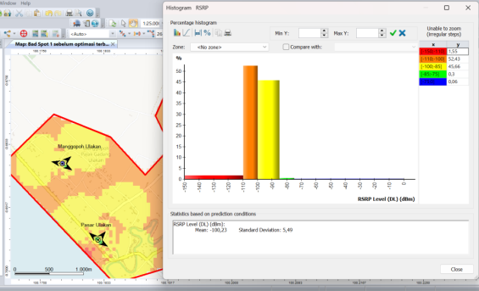
Figure 3. RSRP Optimization Results and Comparison with the Existing Site in Bad Spot 1

The comparison of RSRP parameters before and after the optimization simulation using the ACP method can be seen in the very poor category, where there is a decrease in percentage, while the average value increases from -100.69 dBm to -100.23 dBm after the ACP optimization method is applied, as shown in Table 4.
Table 4. Comparison of RSRP Bad Spot 1
Category | RSRP (dBm) | Site Exsisting | ACP
Excellent | RSRP ≥ -75 | 0,06% | 0,06%
Very Good | -85 ≤ RSRP < -75 | 0,27% | 0,3%
Good | -100 ≤ RSRP < -85 | 47,57% | 45,66%
Fair | -110 ≤RSRP < -100 | 46,32% | 52,43%
Poor | RSRP <-110 | 5,79% | 1,55%

Parameter Results after Optimization using ACP on Bad Spot 2
The results of the optimization simulation using the ACP method for the Bad Spot 2 area for the RSRP (Reference Signal Received Power) parameter, as shown in Figure 4.2.
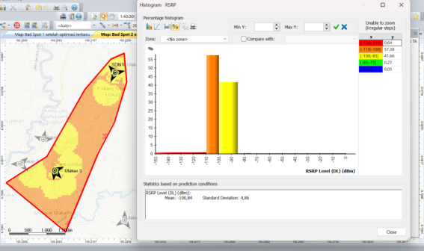
Figure 4. RSRP Optimization Results and Comparison with the Existing Site in the Bad Spot 2 Area

The comparison of RSRP parameters before and after the optimization simulation using the ACP method ACP method can be seen in the very poor category, where there was a decrease in percentage, while the average value increased from -101.13 dBm to -100.84 dBm after the ACP optimization method was applied, as shown in Table 5.
Table 5. Comparison of RSRP Bad Spot 2
Category | RSRP (dBm) | Site Exsisting | ACP
Excellent | RSRP ≥ -75 | 0,05% | 0,05%
Very Good | -85 ≤ RSRP < -75 | 0,09% | 0,27%
Good | -100 ≤ RSRP < -85 | 41,34% | 41,66%
Fair | -110 ≤RSRP < -100 | 55,97% | 57,38%
Poor | RSRP <-110 | 2,54% | 0,64%

The results of the ACP optimization simulation for the RSRQ parameter can be seen in Figure 5.
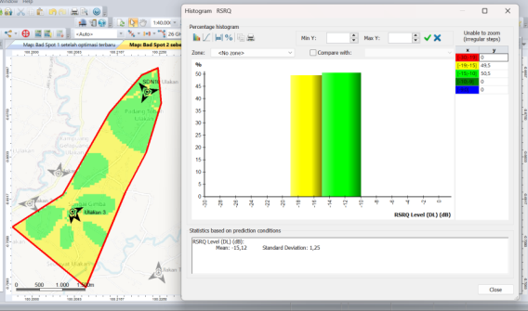
Figure 5. RSRQ Optimization Results and Comparison with Existing Sites in Bad Spot 2 Area

The Comparison of RSRQ parameters before and after optimization simulation using the ACP method can be seen in the very poor category, where there was a decrease in percentage, while the average value increased from -15.21 dB to -15.12 dB after the ACP optimization method was applied, as shown in Table 6.
Table 6. Comparison of RSRQ Bad Spot 2
Category | RSRQ (dB) | Site Exsisting | ACP
Excellent | ≤ -9 | 0% | 0%
Very Good | -10 ≤ RSRQ < -9 | 0% | 0%
Good | --15 ≤ RSRQ < -10 | 47,6% | 50,5%
Fair | -19 ≤ RSRQ < -15 | 52,4% | 49,5%
Poor | < -20 | 0% | 0%

The results of the ACP optimization simulation for the SINR parameter can be seen in Figure 6.
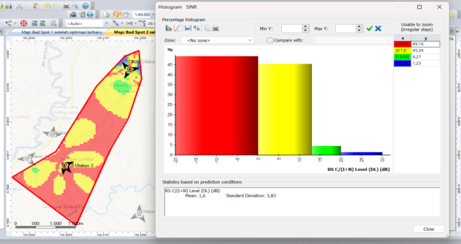
Figure 6. SINR Optimization Results and Comparison with Existing Site in Bad Spot 2 Area

The Comparison of SINR parameters before and after simulation optimization using the ACP method. In the very poor category, there was a decrease in percentage, while the average value increased from -1.21 dB to -1.6 dB after applying the ACP optimization method, as shown in Table 7.
Table 7. Comparison of SINR Bad Spot 2
Category | SINR (dB) | Site Exsisting | ACP
Excellent | SINR >20 | 0,3% | 1,23%
Good | 13 ≤ SINR < 20 | 4,7% | 4,27%
Fair | 0 ≤ SINR < 13 | 42,8% | 45,34%
Poor | SINR <0 | 52,2% | 49,16%

Parameter Results after Optimization using ACP in Bad Spot 3
Optimization simulation results using the ACP method for the Bad Spot 3 area for the RSRP (Reference Signal Received Power) parameter, as shown in Figure 7.
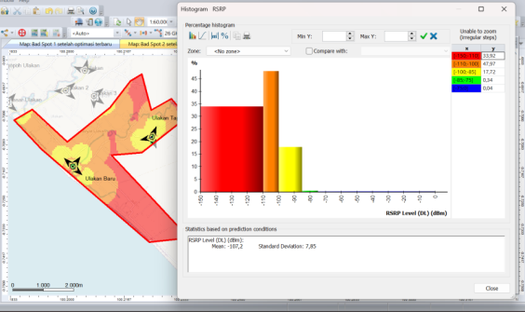
Figure 7. RSRP Optimization Results and Comparison with the Existing Site in the Bad Spot 3 Area

The comparison of RSRP parameters before and after the optimization simulation using the ACP method shows a decrease in percentage for the very poor category, while the average value increased from -109.82 dBm to -107.2 dBm after applying the ACP optimization method, as shown in Table 8.
Table 8. Comparison of RSRP Bad Spot 3
Category | RSRP (dBm) | Site Exsisting | ACP
Excellent | RSRP ≥ -75 | 0,07% | 0,04%
Very Good | -85 ≤ RSRP < -75 | 0,4% | 0,34%
Good | -100 ≤ RSRP < -85 | 16,4% | 17,72%
Fair | -110 ≤RSRP < -100 | 36,3% | 47,97%
Poor | RSRP <-110 | 46,83% | 33,92%

The results of the ACP optimization simulation for the RSRQ parameter can be seen in Figure 8.
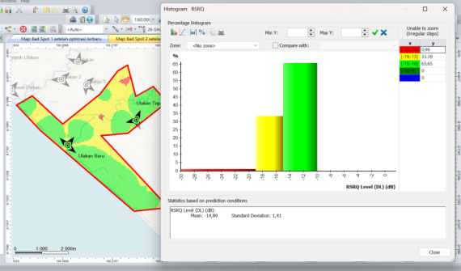
Figure 8. RSRQ Optimization Results and Comparison with Existing Sites in Bad Spot 3 Area

The comparison of RSRQ parameters before and after optimization simulation using the ACP method can be seen in the very poor category, where there was a decrease in percentage, while the average value increased from -15.89 dB to 14.89 dB after the ACP optimization method was applied, as shown in Table 9.
Table 9. Comparison of RSRQ Bad Spot 3
Category | RSRQ (dB) | Site Exsisting | ACP
Excellent | ≤ -9 | 0% | 0%
Very Good | -10 ≤ RSRQ < -9 | 0% | 0%
Good | --15 ≤ RSRQ < -10 | 38,8% | 65,65%
Fair | -19 ≤ RSRQ < -15 | 54% | 33,39%
Poor | < -20 | 7,2% | 0,96%

The results of the ACP optimization simulation for the SINR parameter can be seen in Figure 9.
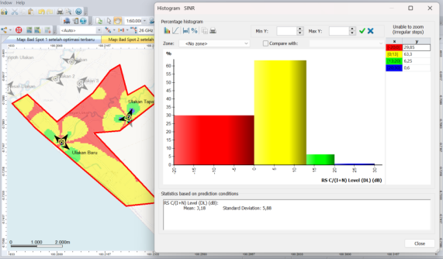
Figure 9. SINR Optimization Results and Comparison with Existing Site in Bad Spot 3 Area

The Comparison of SINR parameters before and after simulation optimization using the ACP method. In the very poor category, there was a decrease in percentage, while the average value increased from 0.48 dB to 3.18 dB after applying the ACP optimization method, as shown in Table 10.
Table 10. Comparison of SINR Bad Spot 3
Category | SINR (dB) | Site Exsisting | ACP
Excellent | SINR >20 | 1,39% | 0,6%
Good | 13 ≤ SINR < 20 | 4,57% | 6,25%
Fair | 0 ≤ SINR < 13 | 36,07% | 63,3%
Poor | SINR <0 | 57,97% | 29,85%

CONCLUSION
The conclusion of the LTE network optimization in Nagari Ulakan and Tapakis, Ulakan Tapakis District, Padang Pariaman Regency, Padang Pariaman, are as follows:
- LTE network in the area shows that 84% of RSRP measurements are above -100 dBm, 85% of RSRQ measurements are above -15 dB, and 73% of SINR measurements are above 0 dB.
- There are three bad spot areas identified based on RSRP, dominated by the very poor (red) and fairly poor (yellow) categories. Bad Spot 1 is served by 4 sites, Bad Spot 2 by 2 sites, and Bad Spot 3 by 6 sites.
- Simulation of existing sites in bad spot areas produced the following average parameters: RSRP Bad Spot 1: -100.69 dBm, Bad Spot 2: -101.13 dBm, Bad Spot 3: -109.82 dBm; RSRQ Bad Spot 2: -15.21 dB, Bad Spot 3: -15.89 dB; SINR Bad Spot 2: 1.21 dB, Bad Spot 3: -0.48 dB.
- After optimization using the Automatic Cell Planning (ACP) method, the average parameters in the bad spot area improved: RSRP Bad Spot 1: -100.23 dBm, Bad Spot 2: -100.84 dBm, Bad Spot 3: -107.2 dBm; RSRQ Bad Spot 2: -15.12 dB, Bad Spot 3: -14.89 dB; SINR Bad Spot 2: -1.6 dB, Bad Spot 3: 3.18 dB.
- This optimization effectively improves network performance in residential areas, reduces coverage gaps, and improves signal quality across all measured KPIs.

REFERENCES

[1] E. C. Alfindo.( 2018) Peningkatan kinerja jaringan LTE dengan metode physical tuning di lingkungan kampus terpadu universitas islam indonesia.
[2] Badan Pusat Statistik Kabupaten Padang Pariaman, “Jumlah Penduduk,” BPS Kabupaten Padang Pariaman, 2025. [Online]. Available: https://padangpariamankab.bps.go.id/id/statisticstable/2/MjkjMg==/jumlah-penduduk.html. [Accessed: Jan. 6, 2026].
[3] Kementerian Pariwisata dan Ekonomi Kreatif Republik Indonesia, Desa Wisata Gtp Ulakan 50 Besar ADWI 2022, Jadesta. [Online]. Available: https://jadesta.kemenparekraf.go.id/desa/gtp_ulakan.[Accessed:Jan.6, 2026].
[4] A. Al-Sobar Ali, K. Kasmita, R. Susanti, dan Y. P. Lisna, “Tinjauan Tingkat Pengetahuan Hygiene Makanan Pedagang Sala Lauak di Objek Wisata Ulakan Padang Pariaman,” J. Kajian Pariwisata dan Perhotelan, vol. 1, no. 3, pp. 95–100, Jan. Apr. 2024.
[5] H. Yuliana et al., “OPTIMASI JARINGAN 4G LTE PADA JALUR TOL CIKOPO PALIMANAN DENGAN MENGGUNAKAN METODE PHYSICAL TUNING,” Jurnal Teknologi Informasi dan Ilmu Komputer, vol. 11, no. 3, pp. 475–486, Jul. 2024, doi: 10.25126/JTIIK.937828.
[6] Fabian, R. N. (2021). Analisis Perbandingan Quality of Service LTE Telkomsel Berdasarkan Parameter KPI. Electro Luceat, 7(1), 127–134.
[7] Koroma, M., & Sawaneh, I. A. (2020). A 4G LTE Evolved packet Core Planning and Deployment in Freetown Sierra Leone. Asian Journal of Interdisciplinary Research, 1–18. https://doi.org/10.34256/ajir20231
[8] R. A. Mursid, I. Uke, K. Usman, and H. Vidyaningtyas, (2019). Performance analysis and optimization for 4g lte network at telkom university region. E-Proceeding of Engineering.6(1), 339–345.
[9] M. Sousa, A. Alves, P. Vieira, M. P. Queluz, and A. Rodrigues,( 2021).Analysis and optimization of 5g coverage predictions using a beamforming antenna model and real drive test measurements. IEEE Access.9, 101 787–101 808.
[10] Lestari, A. P., Dr. Nachwan A, S. M., & Ir. Uke Kurniawan Usman, M. (2018). Metode Collision & Confusion Free Pada Alokasi Physical Cell Identity (PCI), Studi Kasus Jaringan 4G LTEAdvanced 1800 MHz Area Kotamadya Jakarta Timur. e-Proceeding of Engineering, 5(1), 597.
[11] D. Aliansyah, F. Kurniawan, and U. Putra, (2022). Usulan perbaikan layanan lte di jalan daan mogot dari kota tangerang sampai kota jakarta barat. e-Proceeding of Engineering.8(6), 3972–3978.
[12] N. H. Herina, S. Dase, dan Zaini, “Analisis Pengukuran Kinerja Jaringan 4G LTE Berdasarkan Hasil Drive Test,” dalam Prosiding Seminar Nasional Teknik Elektro dan Informatika (SNTEI) 2022, Jurusan Teknik Elektro, Politeknik Negeri Ujung Pandang, 2022, hlm. 97.
[13] Y. Ismemet, Analisis Perbandingan Kualitas Sinyal 4G LTE pada beberapa provider, Tugas Akhir, Program Studi Teknik Elekto, Fakultas Sains dan Teknologi, Universitas Islam Negeri Sultan Syarif Kasim Riau, Pekanbaru, Indonesia, 2022
[14] M. S. Bayudin, A. Fauziah, dan F. R. Fakhrur Razi, “Pengujian Drive Test untuk Menentukan Kualitas Layanan Jaringan 4G LTE di Kota Lhokseumawe,” Jurnal TEKTRO, vol. 5, no. 1, 2021, doi: 10.30811/tektro.v5i1.2796
[15] Sitindjak, H. G., Hadikusuma, R. S., & Saragih, Y. (2021). Perbandingan Software Drive Test Dalam Uji Kualitas Jaringan 3G Menggunakan Provider Telkomsel Comparison of Software Drive Test in 3G Network Quality Test Using Telkomsel Provider. Elektro Telekomunikasi Terapan
[16] H. Putri, I. Ahmad, A. Hikmaturokhman, and D. H. Putri, (2024).Automatic cell planning method for radio network optimization. JOIV, 8(1), 449–455.

